PROJECT DOCUMENTATION
LEARNMATE (AI STUDYBUDDY): AI ASSISTANT FOR SMARTER LEARNING AND STUDY SUPPORT

INTRODUCTION
PROJECT TITLE | LearnMate - AI assistant for smarter learning and study support (AI StudyBuddy)
TEAM ID | NM2025TMID42550
TEAM SIZE | 4
TEAM LEADER | Kalaiyarasi S (kalaiyarasis731@gmail.com)
TEAM MEMBER 1 | Subasree M (subasree995@gmail.com)
TEAM MEMBER 2 | Thasmiya G (thasmiya12kgi@gmail.com)
TEAM MEMBER 3 | Vidhya K (vv1584109@gmail.com)

PROJECT OVERVIEW

Purpose and Features
AI StudyBuddy is an AI-powered learning assistance platform that simplifies the study process for students using modern web technologies and Generative AI. Students can upload study materials and receive concise summaries, flashcards, quizzes and personalized study plans generated by the Google Gemini API.

Purpose of the LearnMate App
- AI Content Generation: Automatically generate summaries, flashcards, quizzes and study plans from study material.
- Study Material Management: Upload and store notes (.txt, .md, .pdf) in one centralized place.
- Secure Access: JWT authentication with bcryptjs password hashing and role-based access control.
- Data Centralization: MongoDB is the single source of truth for users, materials and generated resources.
- Scalability: Modular REST architecture that supports future AI-powered learning features.

Key Features (Backend: Node.js + MongoDB, JSON API)
FEATURE | DESCRIPTION
User Authentication & Roles | JWT-based login and registration; Student vs. Admin (RBAC).
Study Material Management | Upload, retrieve, update and manage study materials.
AI Summary Generation | Concise, easy-to-understand summaries via Google Gemini.
AI Flashcard Generation | Question/answer flashcards for active recall.
AI Quiz Generation | Multiple-choice quizzes to self-assess knowledge.
AI Study Plan Generation | Personalized plans based on goals, hours per day and exam timeline.
FEATURE | DESCRIPTION
JSON REST API | All data exposed as JSON through secure REST endpoints.
Administrative APIs | Admin-only endpoints to manage users and monitor system activity.
History & Saved Resources | Generated resources are stored and retrievable anytime.

Frontend Features (React.js)
- Register / Login pages with JWT session handling.
- Dashboard for uploading study material and accessing all AI features.
- Views for summaries, flashcards, quizzes (attempt and results) and study plans.
- History page for all saved learning resources, plus profile management.

Typical Tech Stack
- Backend: Node.js + Express.js
- Database: MongoDB with Mongoose ODM
- AI: Google Gemini 2.5 Flash API (@google/genai)
- Security: jsonwebtoken, bcryptjs, cors; file uploads via multer
- Data Format: JSON for API communication
- Frontend: React.js

Scenario-Based Case Study
Rahul, a second-year engineering student, has study material scattered across lecture notes, PDFs, textbooks and articles. He struggles to identify key concepts, make revision notes, create practice questions and plan his revision within limited time. AI StudyBuddy centralizes his material and automates summaries, flashcards, quizzes and study plans, reducing manual effort and improving learning outcomes.
Student usage: register, log in, upload or enter content, choose an AI function, review results and save them. Administrator usage: manage user accounts, monitor AI service utilization, review system logs and maintain platform integrity.

ARCHITECTURE
The backend follows a modular RESTful, client-server architecture. Requests pass through
Express.js, are validated with JWT authentication, interact with MongoDB for storage, and call the Google Gemini API to generate study resources. Authentication, business logic, AI services and database operations are separate modules.

Core Concepts & Components
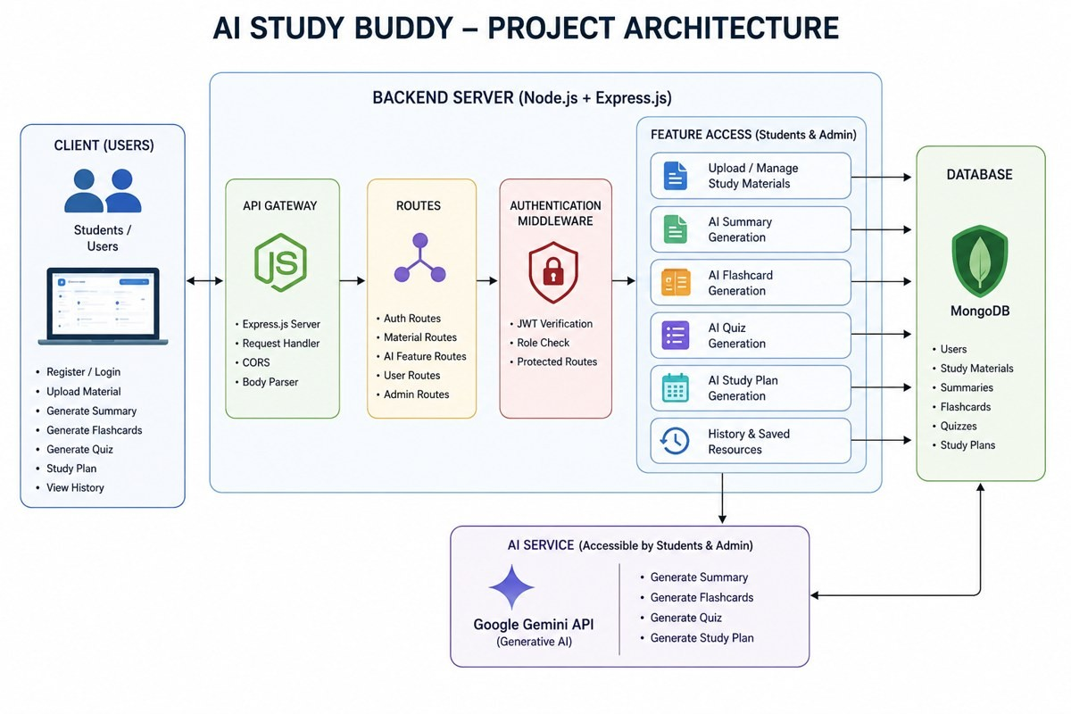
Figure 1: AI StudyBuddy - Project Architecture
- Client Application (React.js): register, log in, upload material and use AI features through REST APIs.
- Express Server: receives HTTP requests, routes them, runs middleware and returns responses.
- Authentication Middleware: verifies JWT tokens, protects private routes and enforces admin-only access.
- Route Handlers: /api/auth, /api/materials and /api/admin.
- AI Service Layer: communicates with Google Gemini to generate summaries, quizzes, flashcards and study plans.
- Database Layer: MongoDB with Mongoose schemas for validation and data modeling.

MVC Architecture Pattern

- Model: Mongoose schemas (User, Material) for MongoDB collections.
- View: JSON API responses consumed by the React frontend.
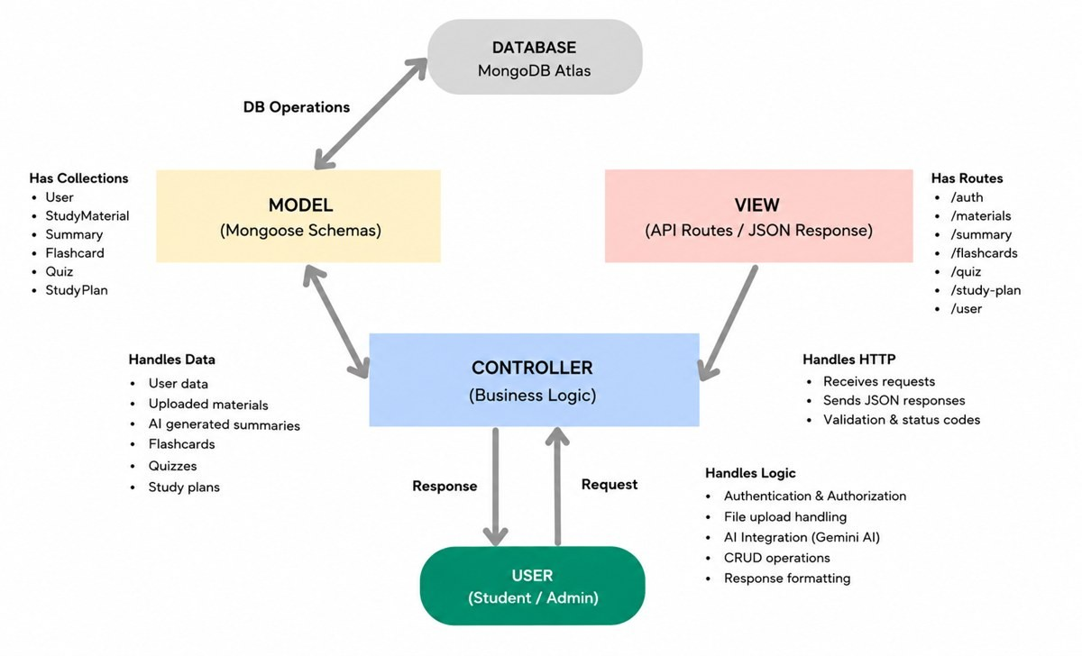
- Controller: business logic: validation, authentication, file handling, Gemini calls and CRUD operations.
Figure 4: MVC Architecture Pattern

Entity-Relationship Description
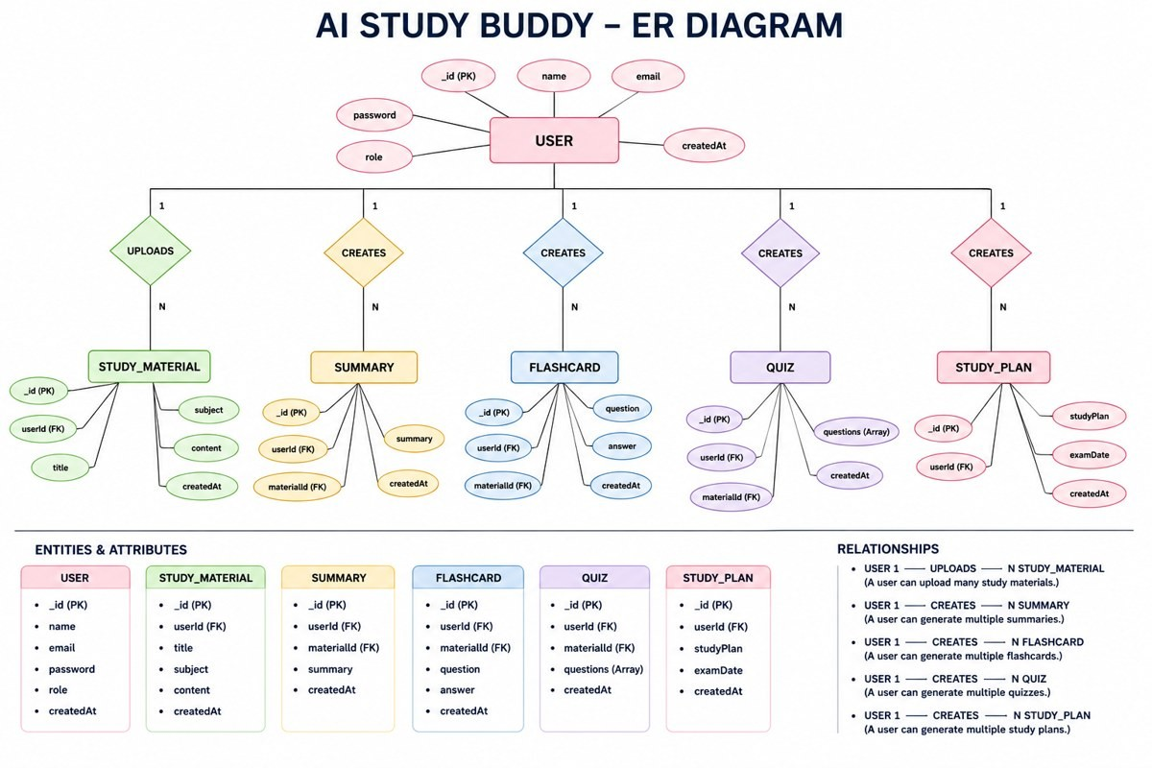
Figure 2: AI StudyBuddy - ER Diagram
ENTITY | ATTRIBUTES
User | _id, name, email (unique), password (hashed), role (student/admin), createdAt
Study Material | _id, userId (FK), title, subject, content, createdAt
Summary | _id, userId (FK), materialId (FK), summary, createdAt
Flashcard | _id, userId (FK), materialId (FK), question, answer, createdAt
Quiz | _id, userId (FK), materialId (FK), questions (array), createdAt
Study Plan | _id, userId (FK), studyPlan, examDate, createdAt
- User to Study Material: one-to-many.
- Study Material to Summary: one-to-one; to Flashcards: one-to-many; to Quiz: one-to-one.
- User to Study Plan: one-to-many; all AI resources are linked to the user who generated them.

User Flow
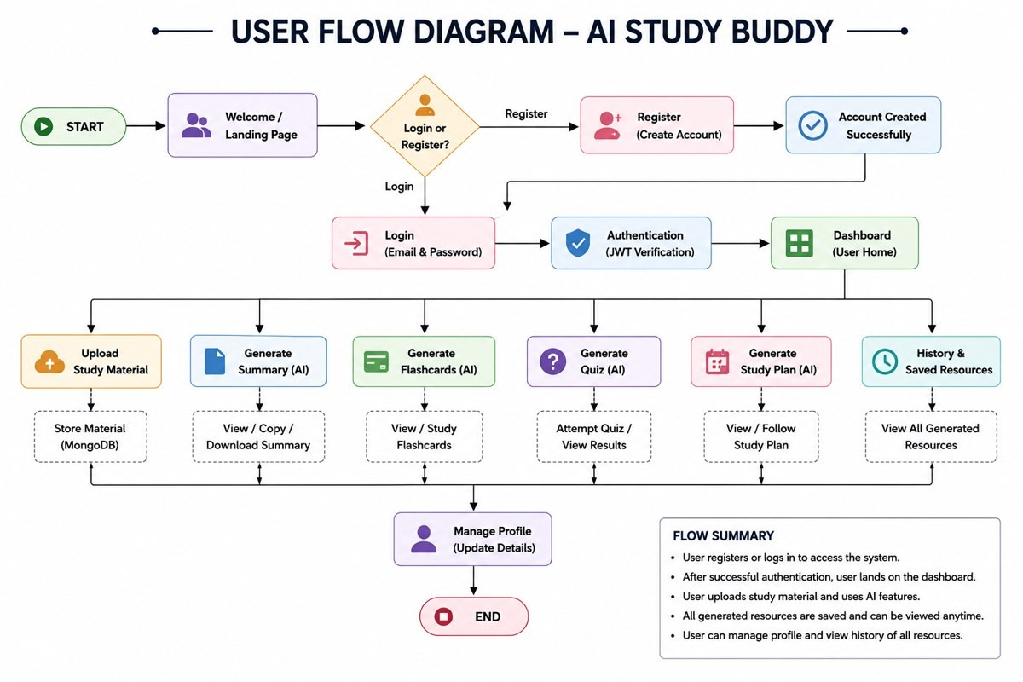
Figure 3: User Flow Diagram - AI StudyBuddy
Start, then Landing Page, then Login/Register, then JWT verification, then Dashboard. From the dashboard the user can upload material, generate a summary, flashcards, a quiz or a study plan, view history and saved resources, and manage their profile.

STEP INSTRUCTIONS

Prerequisites
- Node.js (v16 or above) and npm (v8 or above)
- MongoDB (local or MongoDB Atlas)
- Express.js, Postman (API testing), Visual Studio Code
- Google Gemini API key
- Hardware: Intel Core i5 8th Gen / Ryzen 5 or equivalent, 8 GB RAM minimum (16 GB recommended), 1 GB free disk space
- OS: Windows 10/11, macOS or Linux

Installation Steps
1. Create a folder named AI StudyBuddy and open it in Visual Studio Code. 2. Initialize the project and install dependencies:
npm init -y npm install express mongoose bcryptjs jsonwebtoken cors dotenv multer @google/genai npm install --save-dev nodemon
- Create the files index.js, .env, package.json and .gitignore, and the folder structure:
AI-STUDYBUDDY/ src/ controllers/ adminController.js, authController.js, materialController.js middleware/ auth.js, upload.js models/ Material.js, User.js routes/ admin.js, auth.js, materials.js utils/ db.js, gemini.js, tokens.js .env index.js
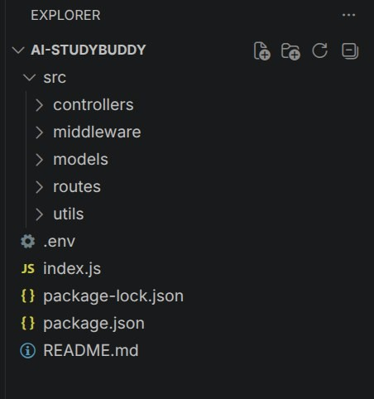
package.json
Figure 5: Project folder structure
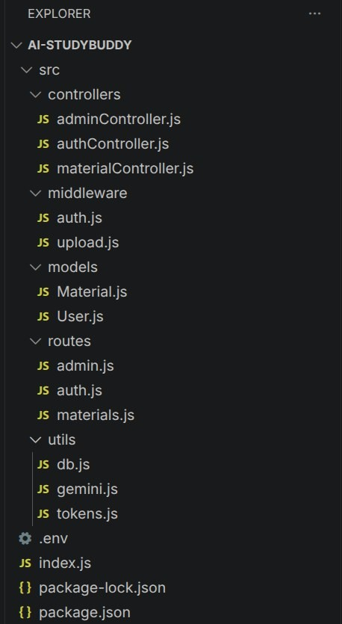
Figure 6: Backend structure (controllers, middleware, models, routes, utils)
- Configure the .env file:
PORT=5000
MONGO_URI=your_mongodb_connection_string
JWT_SECRET=your_jwt_secret
GEMINI_API_KEY=your_gemini_api_key
- Run the server:
npm install npm start

Code Explanation (Module by Module)
- index.js: entry point. Loads environment variables, applies express.json() and CORS, registers /api/auth, /api/materials and /api/admin, adds a health-check route and a global error handler, and starts the server after the database connects.
- src/utils/db.js: connects to MongoDB using mongoose.connect(process.env.MONGO_URI).
- src/middleware/auth.js: protect checks the Bearer token and verifies the JWT (401 if missing or invalid); adminOnly returns 403 unless the user's role is admin.
- src/utils/gemini.js: wraps the Gemini 2.5 Flash model; askGemini(prompt) sends a prompt and returns the text response.
- src/middleware/upload.js: multer disk storage into uploads/; accepts only .txt, .md and .pdf files with a 5 MB limit.
- models/User.js: name, email (unique, lowercase), password, role (student/admin); password is hashed with bcrypt before saving and a matchPassword method compares logins.
- models/Material.js: user (ref), title, content, filename, summary, flashcards [question, answer], quiz [question, options, answer], studyPlan, with timestamps.

Code Screenshots
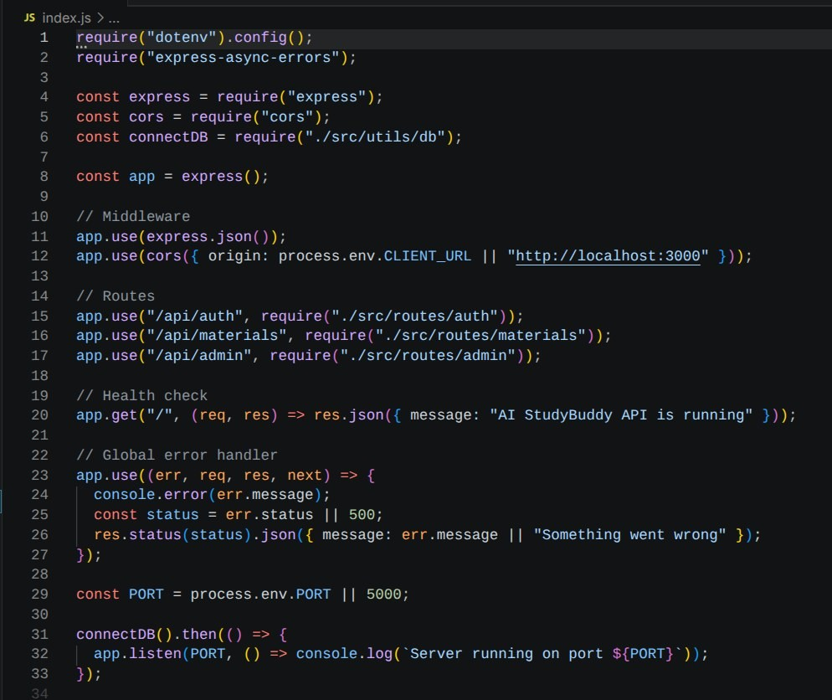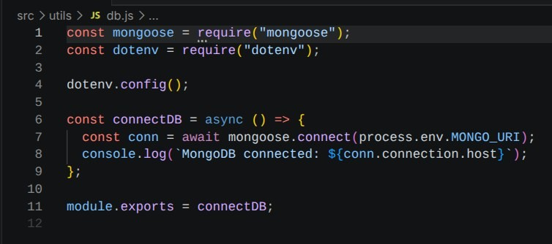
Figure 7: index.js - application entry point
Figure 8: src/utils/db.js - database connection
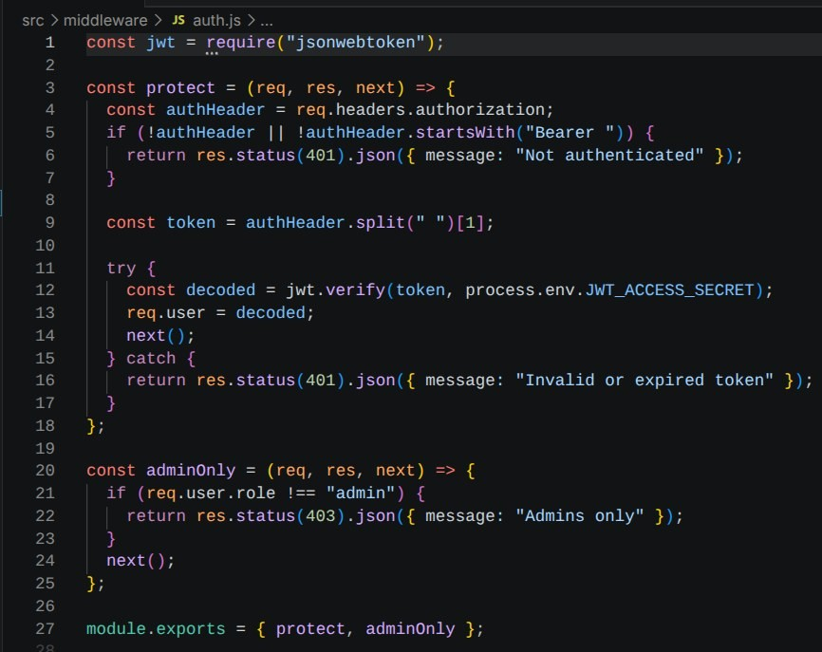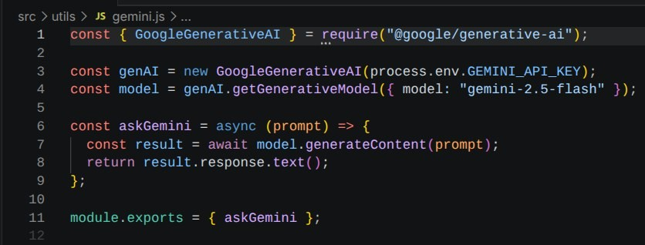
Figure 9: src/middleware/auth.js - authentication middleware
Figure 10: src/utils/gemini.js - Gemini AI integration
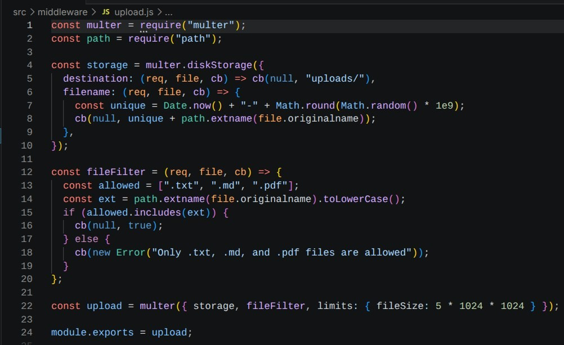
Figure 11: src/middleware/upload.js - file upload middleware
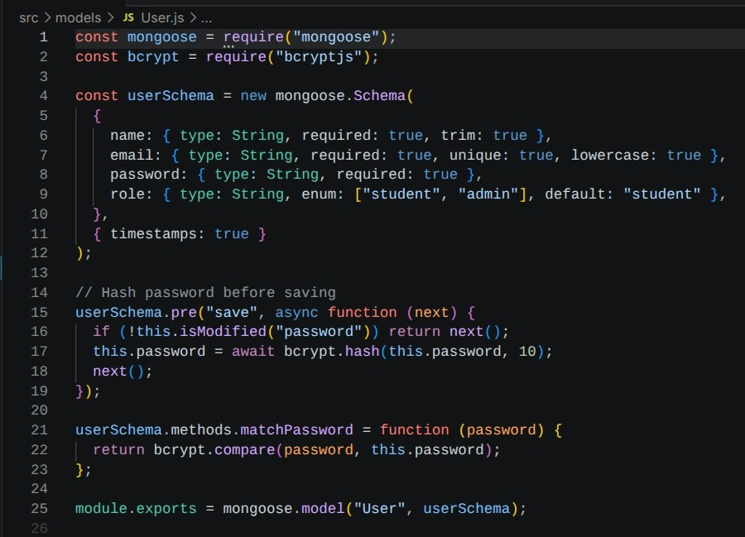
Figure 12: models/User.js - User schema
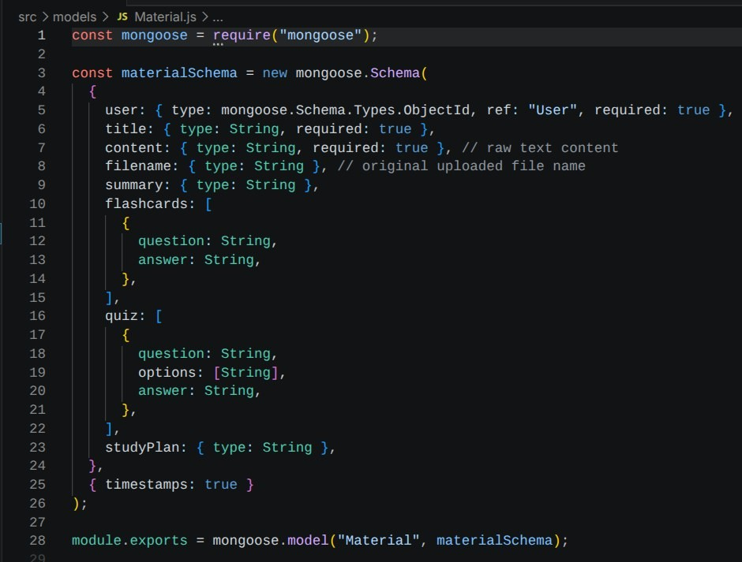
Figure 13: models/Material.js - Study Material schema

Database Collections
- Users: account and authentication details.
- Study Materials: uploaded content and generated learning resources.

API ENDPOINTS AND TESTING (POSTMAN)
# | FEATURE | ENDPOINT | DESCRIPTION
1 | User Registration | POST /api/auth/register | Registers a user; password stored encrypted; returns access and refresh tokens (201 Created).
2 | User Login | POST /api/auth/login | Authenticates the user and returns a JWT access token (200 OK).
3 | Upload Study  Material | POST /api/materials/upload | Authenticated form-data upload (file + title); stores content (201 Created).
4 | Generate AI  Summary | POST  /api/materials/:id/summarize | Sends material to Gemini and returns a concise summary.
5 | Generate AI  Flashcards | POST  /api/materials/:id/flashcards | Returns question/answer flashcards.
# | FEATURE | ENDPOINT | DESCRIPTION
6 | Generate AI Quiz | POST /api/materials/:id/quiz | Returns multiple-choice questions with options and answer.
7 | Generate AI Study  Plan | POST  /api/materials/:id/study-plan | Body: goal, hoursPerDay, days; returns a personalized schedule.
8 | Administrative APIs | /api/admin/* | Admin-only user management and monitoring.
Example study-plan request body:
{
"goal": "Prepare for my backend development exam",
"hoursPerDay": 2,
"days": 7
}
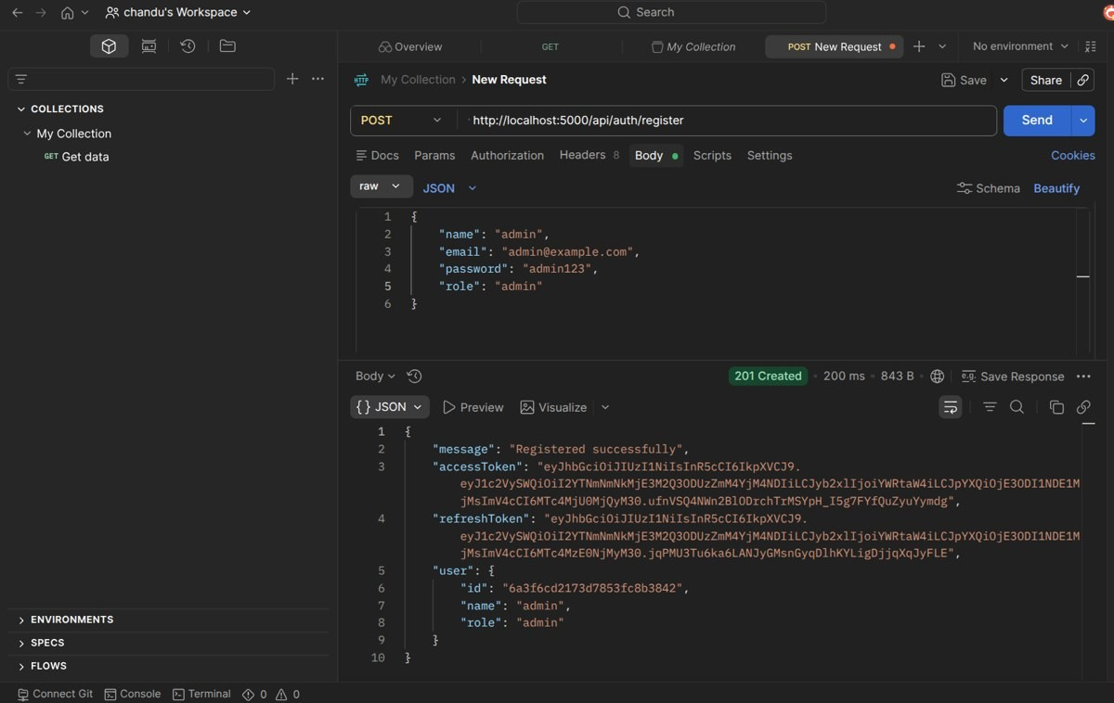
Postman Output Screenshots
Figure 14: User Registration - POST /api/auth/register (201 Created)
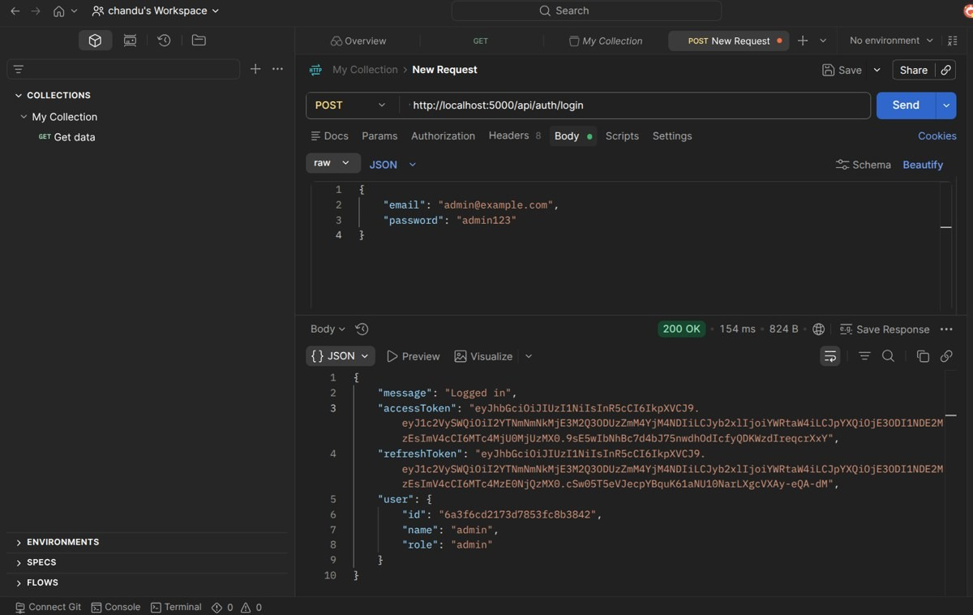
Figure 15: User Login - POST /api/auth/login (200 OK)
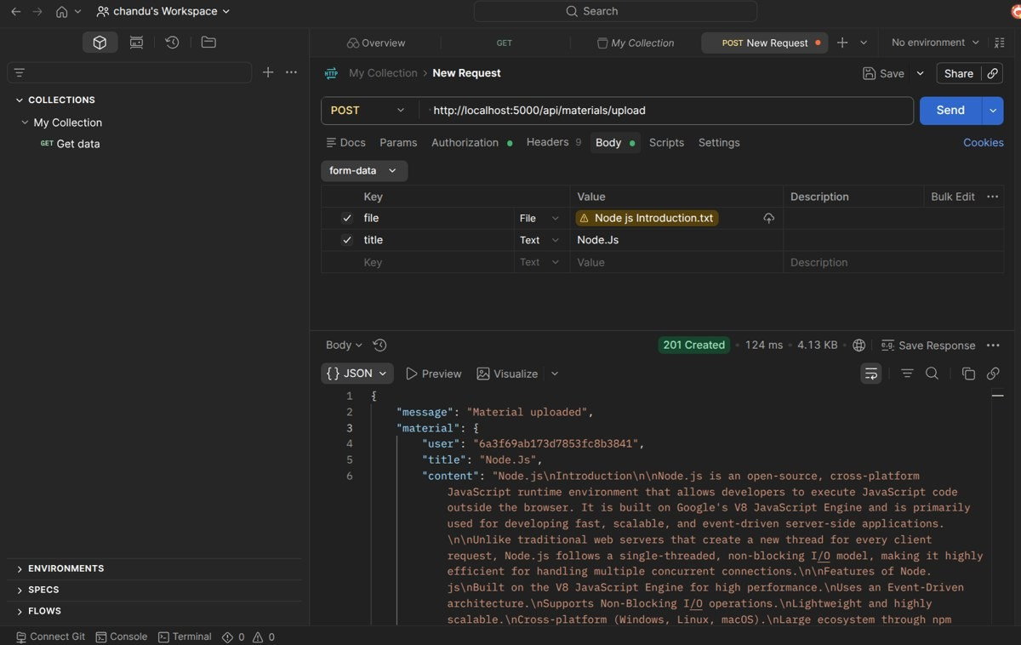
Figure 16: Upload Study Material - POST /api/materials/upload (201 Created)

Figure 17: Generate AI Summary - material upload response used as input for POST /api/materials/:id/summarize
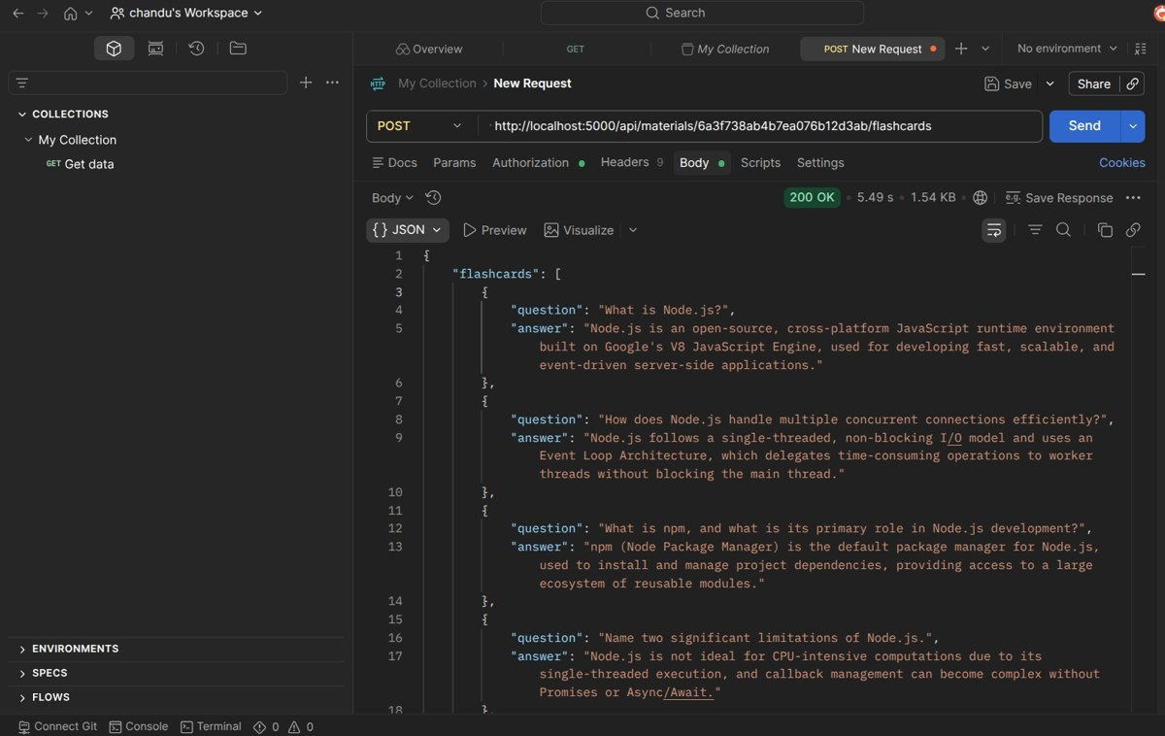
Figure 18: Generate AI Flashcards - POST /api/materials/:id/flashcards (200 OK)
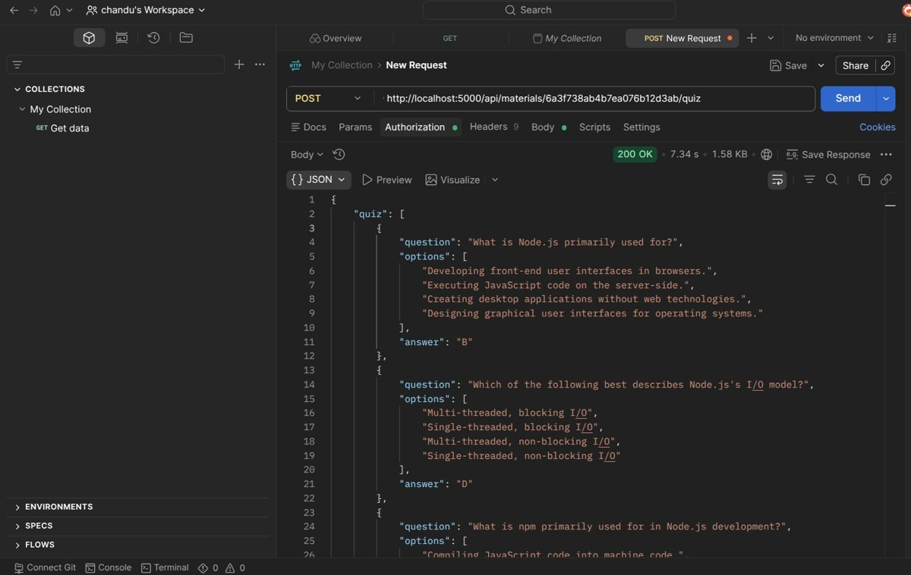
Figure 19: Generate AI Quiz - POST /api/materials/:id/quiz (200 OK)
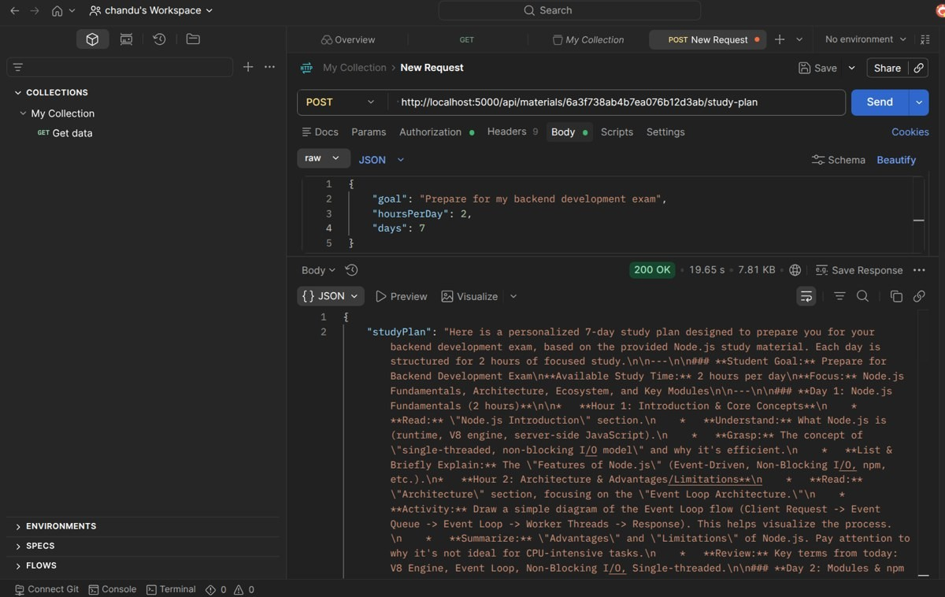
Figure 20: Generate AI Study Plan - POST /api/materials/:id/study-plan (200 OK)

OUTPUT ANALYSIS
- Server start: the console shows the MongoDB connection message and the port the server is running on (5000).
- Registration / login: return a success message, access token, refresh token and user object (id, name, role).
- Upload: returns "Material uploaded" with the stored material (user, title, content).
- Flashcards: a JSON array of question/answer pairs (for example, "What is Node.js?").
- Quiz: a JSON array of questions, four options each, and the correct answer letter.
- Study plan: a day-by-day schedule with focus topics, activities and review points for the requested hours per day.

Demo Links
- Backend demo: AI_Studybuddy_Backend_Demo.mkv
- API testing: AI_Studybuddy_Execution_Demo.mkv
- Demo video: https://drive.google.com/file/d/11ShkBRp-qSXogvOqFn4InZa3CQok1GFr/view?usp=drive_link • Code: Drive folder (linked in the original document)

CONCLUSION
The LearnMate (AI StudyBuddy) backend, built with Node.js, Express.js and MongoDB and integrated with the Google Gemini API, provides a secure, scalable and intelligent way to support student learning. JWT authentication, role-based access and a modular MVC structure keep the system safe and maintainable.
This approach allows students to:
- Turn raw study material into summaries, flashcards and quizzes automatically.
- Follow personalized study plans based on their goals and available time.
- Store and revisit all generated resources in one place.
- Save time on manual note preparation and focus on understanding concepts.
Because it is built on widely used technologies, it can be extended with new AI-powered learning features and grow with its users.

